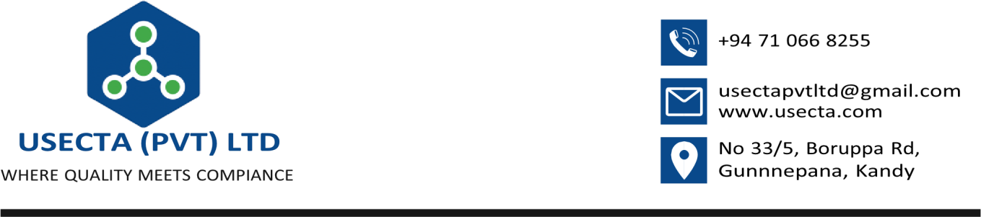

Chairman – Procurement Committee {{ document_date }}
State Pharmaceutical Manufacturing Corporation

No.11, Sir John Kotelawala Mawatha Kandawala Estate, Ratmalana, Sri Lanka
Dear Sir/ Madam,

Authorization to Represent USECTA (Pvt) Ltd for Tender {{ bid_reference }}

This is to confirm that M.G. Pavith Adeesha (NIC 200023404497) is the duly authorized representative of USECTA (Pvt) Limited. He is authorized to accept and submit all bid documents, required forms, and security submissions related to the tender {{ bid_reference }}, specifically for
{%p for item in tender_items %}
{{ item.item_number }} – {{ item.description }}
{%p endfor %}
Please accept this letter as official confirmation of his authority to act on behalf of the company for the above tender process.
Thank you. Yours faithfully

Adeesa M.G.P
Director – USECTA (Pvt) Ltd

